Ex.no:9 | MINI PROJECT – HEALTHCARE  DATA ANALYTICS
Date: | MINI PROJECT – HEALTHCARE  DATA ANALYTICS

Domain and Problem Statement:
Domain: Healthcare Data Analytics
Problem Statement: Healthcare organizations face challenges in efficiently analyzing patient records, hospital performance, billing patterns, admission trends, and patient outcomes due to the large volume of healthcare data. This project addresses these challenges by transforming raw patient records into structured business intelligence using Python, SQL Server, Power BI, and Tableau to evaluate patient demographics, hospital and medical condition trends, billing patterns, admission types, and overall healthcare performance.
Dataset Description:
Dataset Name: Healthcare Dataset
Granularity: Each row represents a single patient hospital record.
Timeframe Covered: 2019 to 2024.
Key Entities & Attributes:
- Patient Demographics: Name, Age, Gender, Blood_Type, Age_Group
- Medical Details: Medical_Condition, Medication, Test_Results
- Hospital Details: Doctor, Hospital, Room_Number, Admission_Type
- Admission & Discharge: Date_of_Admission, Discharge_Date, Length_of_Stay
- Financial Details: Billing_Amount
- Insurance: Insurance_Provider
Data Source:
Primary Source: Kaggle Open Datasets (Healthcare Dataset).
Data Processing: The dataset was cleaned and transformed using Python and Pandas. Duplicate records and invalid negative billing values were removed, date fields were converted into proper date formats, and additional attributes such as Length of Stay and Age Group were created.
Storage Infrastructure: The cleaned healthcare records were imported into a local SQL Server database (HealthcareDB) and subsequently used for analysis and visualization in Power BI and Tableau.
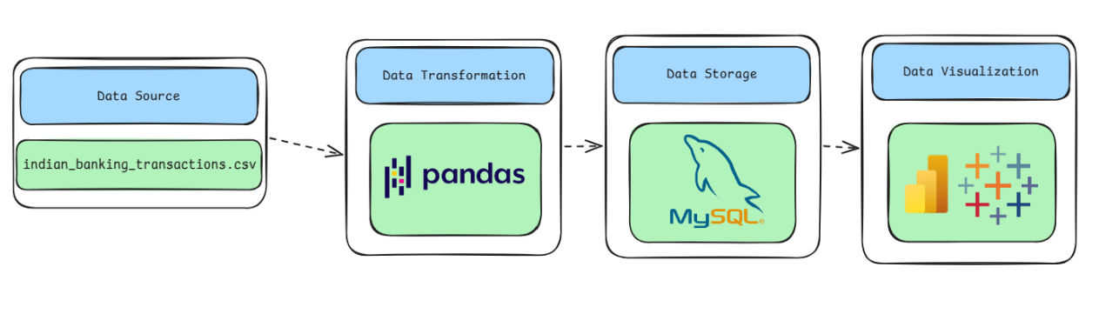
Architecture:

Healthcare Dataset

Program:
1. Python – Data Cleaning & Transformation
import pandas as pd
# Load dataset
df = pd.read_csv("healthcare_dataset.csv.zip")
# Create a copy
healthcare = df.copy()
# Rename columns
healthcare.columns = [
"Name", "Age", "Gender", "Blood_Type",
"Medical_Condition", "Date_of_Admission",
"Doctor", "Hospital", "Insurance_Provider",
"Billing_Amount", "Room_Number",
"Admission_Type", "Discharge_Date",
"Medication", "Test_Results"
]
# Check duplicate records
print("Duplicate records:", healthcare.duplicated().sum())
# Remove duplicates
healthcare.drop_duplicates(inplace=True)
# Convert date columns
healthcare["Date_of_Admission"] = pd.to_datetime(
healthcare["Date_of_Admission"],
errors="coerce"
)
healthcare["Discharge_Date"] = pd.to_datetime(
healthcare["Discharge_Date"],
errors="coerce"
)
# Create Length of Stay
healthcare["Length_of_Stay"] = (
healthcare["Discharge_Date"] -
healthcare["Date_of_Admission"]
).dt.days
# Create Age Group
healthcare["Age_Group"] = pd.cut(
healthcare["Age"],
bins=[0, 18, 30, 45, 60, 75, 100],
labels=["0-18", "19-30", "31-45",
"46-60", "61-75", "76-100"]
)
# Remove invalid negative billing values
healthcare = healthcare[
healthcare["Billing_Amount"] >= 0
].copy()
# Standardize text values
healthcare["Name"] = healthcare["Name"].str.title()
text_columns = [
"Gender",
"Blood_Type",
"Medical_Condition",
"Admission_Type",
"Test_Results"
]
for column in text_columns:
healthcare[column] = healthcare[column].str.title()
# Display final dataset information
print("Final Shape:", healthcare.shape)
print(healthcare.head())
Output:
Final Shape: (54860, 17)
The cleaned dataset contains 54,860 records and 17 columns after removing duplicate records and invalid negative billing values. Additional fields such as Length of Stay and Age Group were created for analysis.

2. SQL Server – Data Storage
The cleaned healthcare dataset was imported into SQL Server.
Database: HealthcareDB
Table: healthcare_cleaned
SELECT COUNT(*) AS Total_Rows
FROM dbo.healthcare_cleaned;
Output:
Total_Rows
----------
54860
3. Power BI – Data Visualization
The cleaned healthcare data was connected from SQL Server to Power BI using Import mode.
DAX measures were created for:
Total Patients = COUNTROWS(healthcare_cleaned)
Total Billing = SUM(healthcare_cleaned[Billing_Amount])
Average Billing = AVERAGE(healthcare_cleaned[Billing_Amount])
Average Length of Stay =
AVERAGE(healthcare_cleaned[Length_of_Stay])
A calculated column was also created for billing classification.
The dashboard includes KPI cards, bar charts, pie charts, line charts, filters/slicers, and interactive visualizations.
4. Tableau – Data Visualization
The cleaned healthcare dataset was loaded into Tableau and used to create interactive worksheets and a dashboard.
The visualizations include:
- Patients by Medical Condition
- Patients by Admission Type
- Gender Distribution
- Total Patients by Year
- Average Billing by Medical Condition
- Billing vs Length of Stay
A Billing Threshold parameter and Billing Category calculated field were also created to provide interactive analysis.

Procedure:
Step 1: Data Preparation & Preprocessing (Python / Pandas)
- Load the raw healthcare dataset using pd.read_csv().
- Inspect the dataset structure, columns, data types, and missing values.
- Identify and remove duplicate patient records.
- Convert admission and discharge dates into proper datetime format.
- Create a Length of Stay attribute from admission and discharge dates.
- Create Age Group categories for patient demographic analysis.
- Identify and remove invalid negative billing values.
- Standardize categorical and text values for consistent analysis.
- Save the cleaned dataset as healthcare_cleaned.csv.
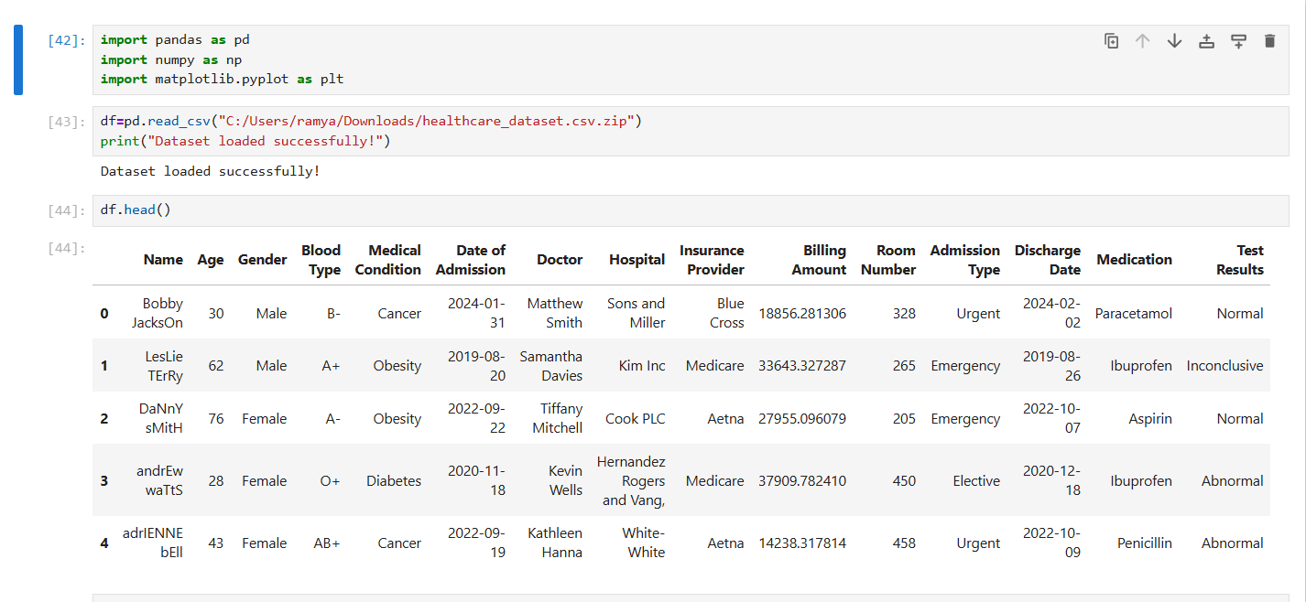
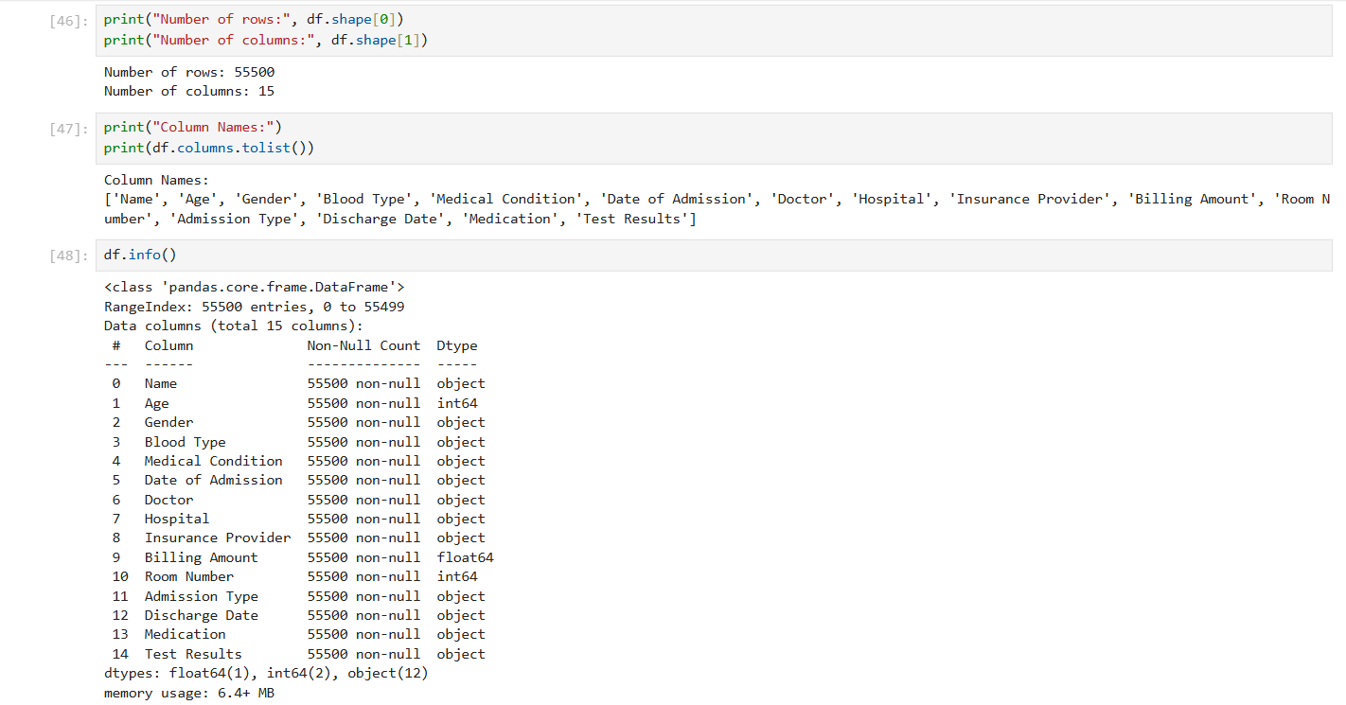
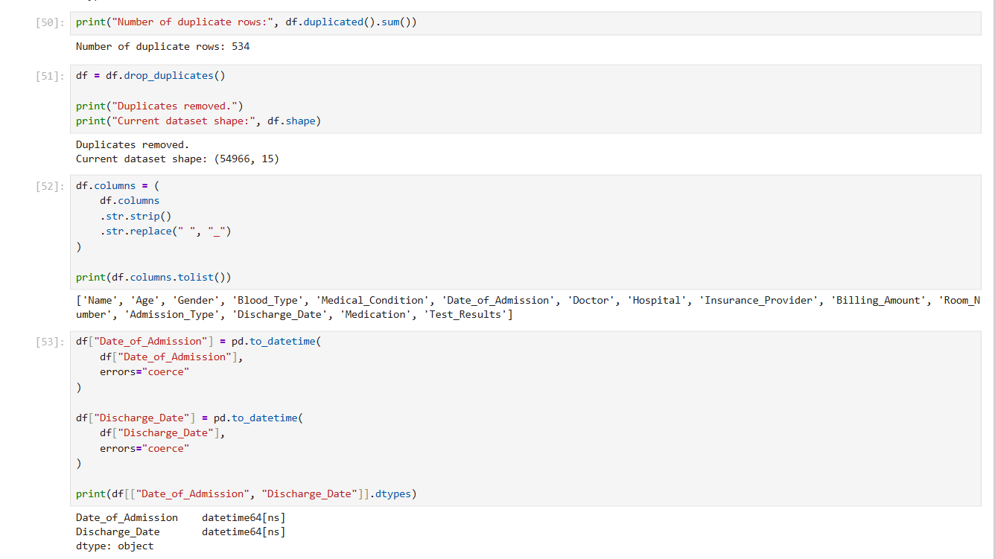

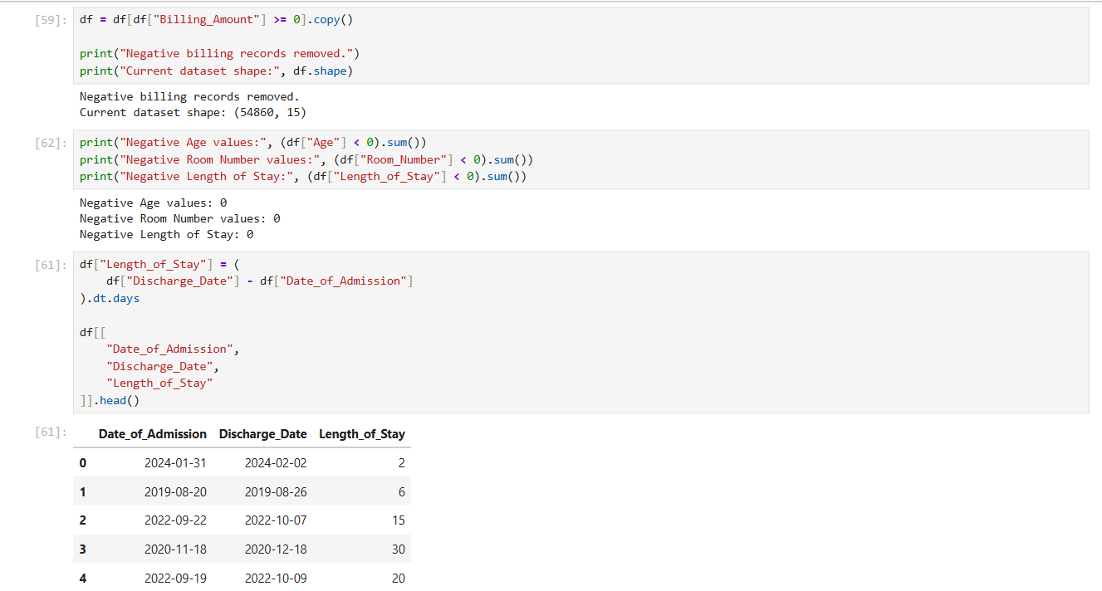
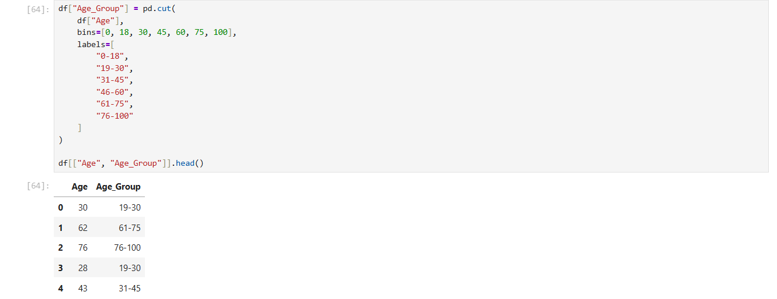

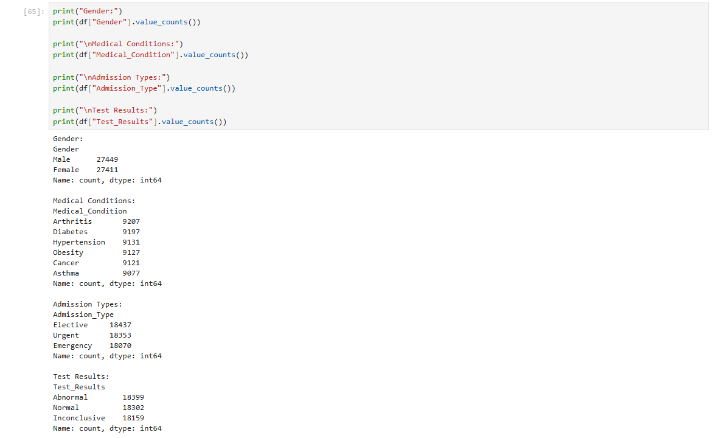

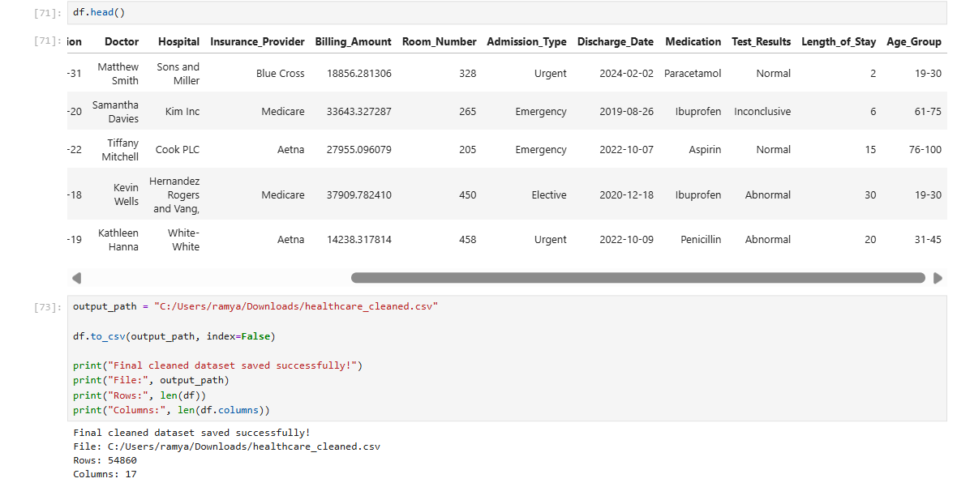

Step 2: SQL Database Connection & Data Ingestion
- Open Power BI Desktop → click Get Data → select SQL Server.
- Enter the server name as localhost and connect to the HealthcareDB database.
- Select the dbo.healthcare_cleaned table from the Navigator window.
- Choose Import mode and click Load to load the cleaned data into Power BI.
- Verify the imported columns and data types in Power BI.
- Use the imported dataset for further DAX calculations and dashboard development.
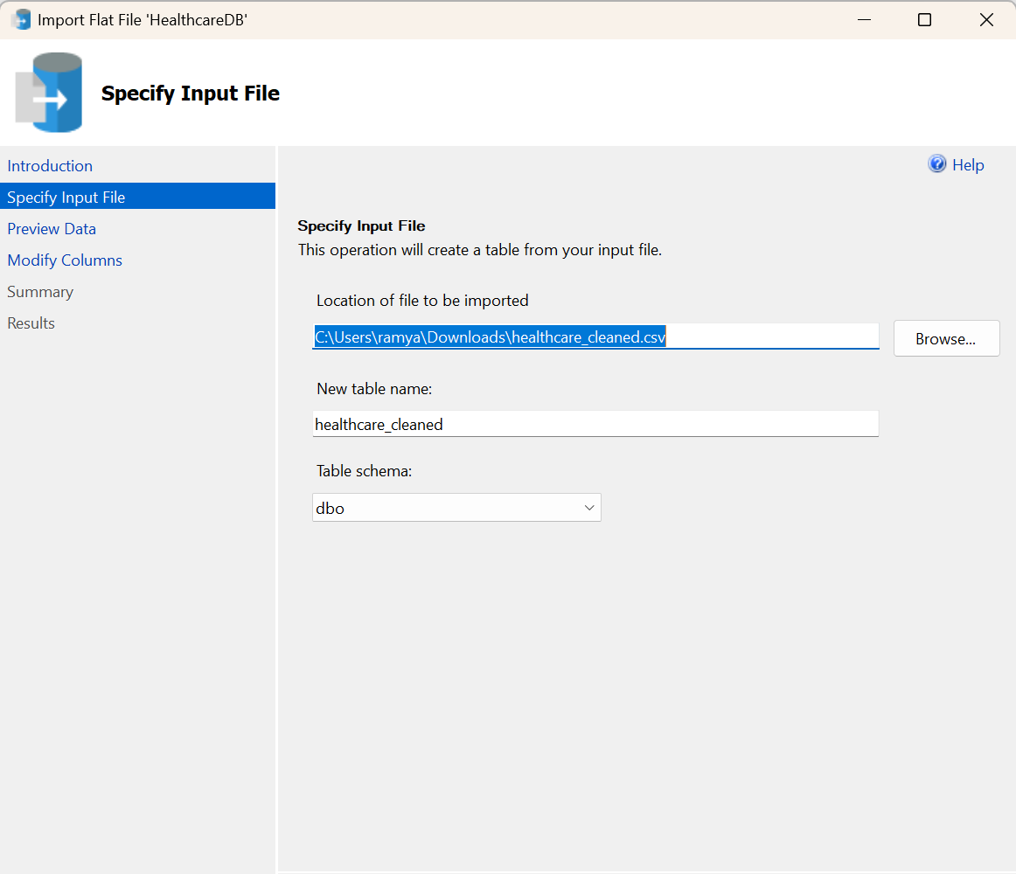

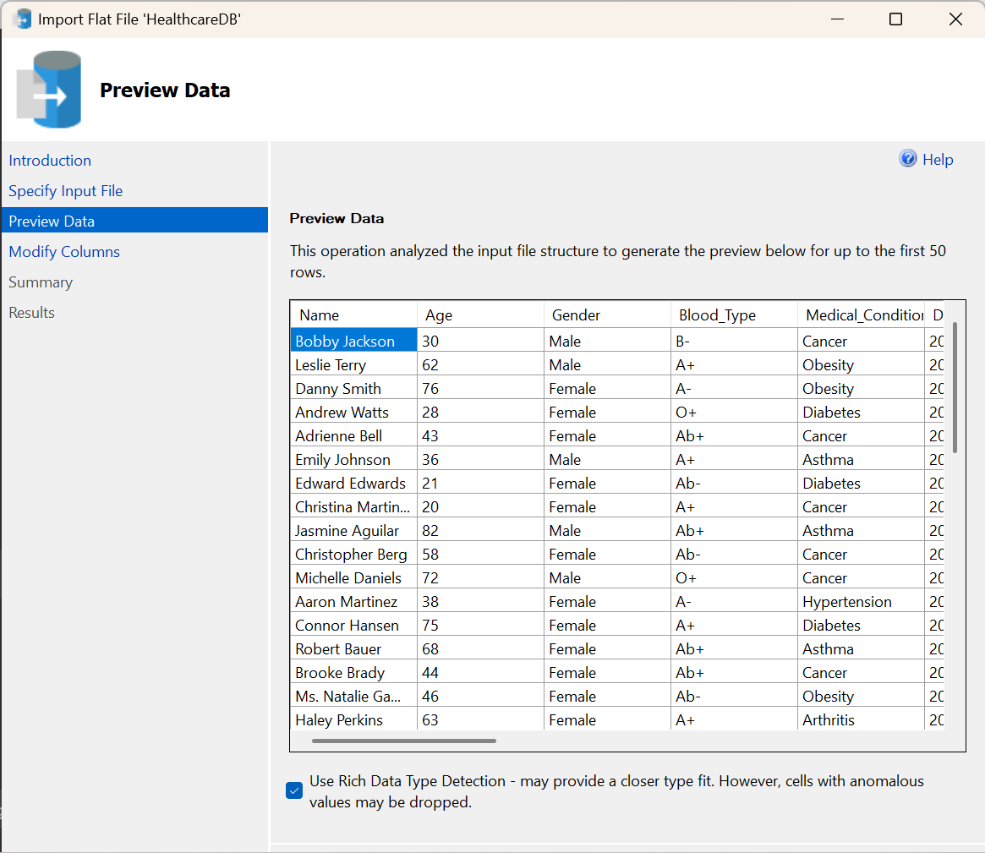

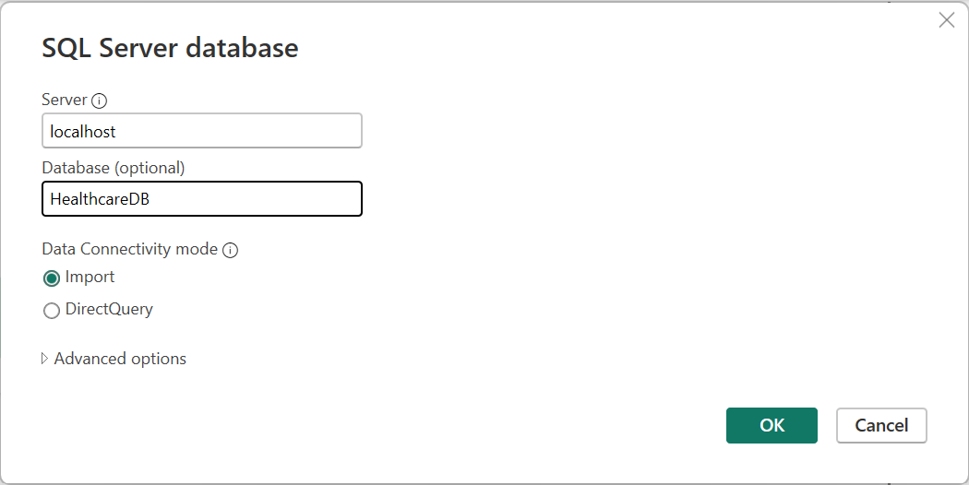

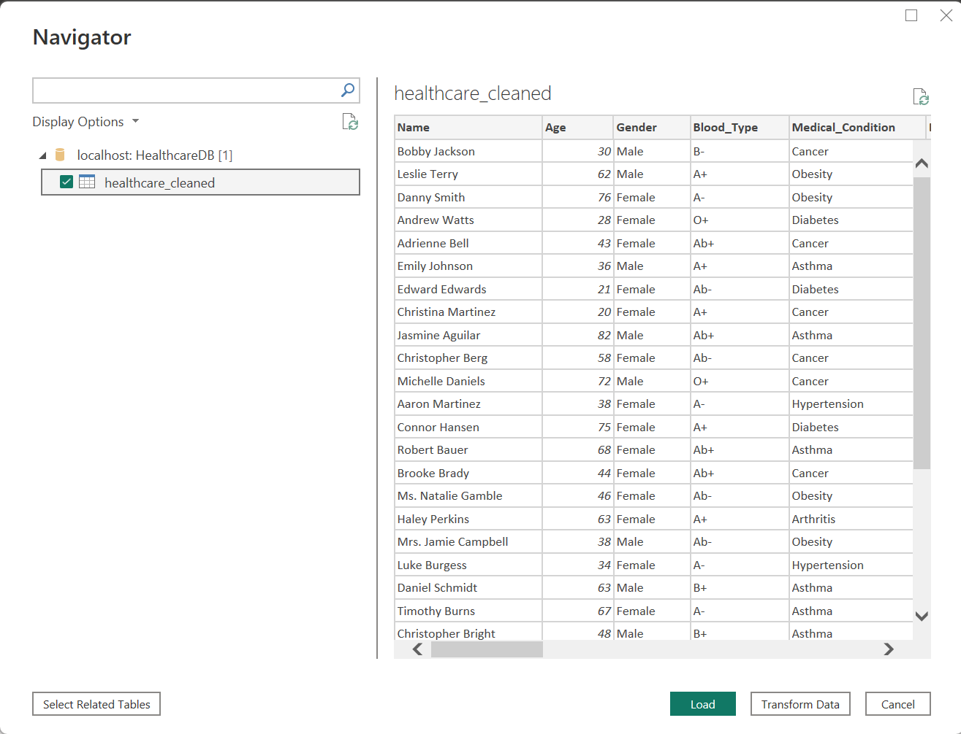

Step 3: Star Schema Data Modeling (Power BI)
- Data Model Preparation:
- Load the healthcare_cleaned table into Power BI.
- Verify the columns, data types, and relationships available in the dataset.
- Use the cleaned dataset as the primary table for analysis.
- Creation of Measures:
- Create a Total Patients measure to calculate the total number of patient records.
- Create a Total Billing measure to calculate the total billing amount.
- Create an Average Billing measure to calculate the average patient billing.
- Create an Average Length of Stay measure to calculate the average duration of hospital stay.
- Create a High Billing Patients measure to identify patients in the high-billing category.
- Calculated Column:
- Create a Billing Category calculated column to classify records into High Billing and Normal Billing based on the billing amount.
- Interactive Analysis:
- Add slicers for Gender, Medical Condition, and Hospital.
- Configure the dashboard visuals to respond interactively to the selected filters.

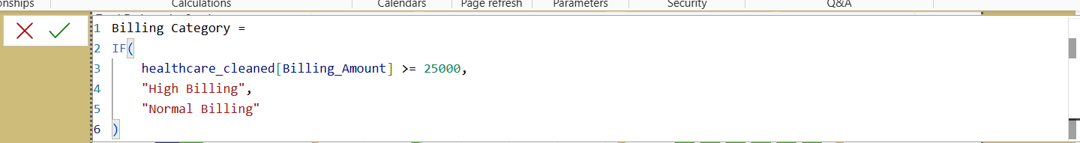

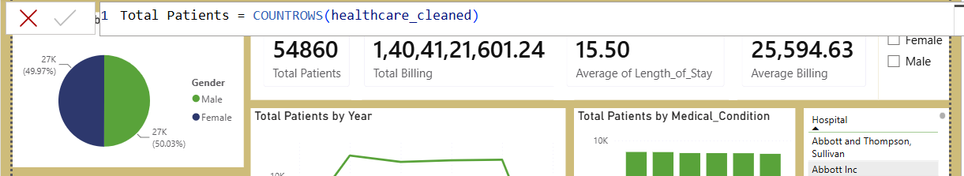

Step 4: Power BI Final Executive Dashboard
- Executive Canvas:
  - Place Card Visuals across the top: Total Patients, Total Billing, Average Length of stay, Average Billing
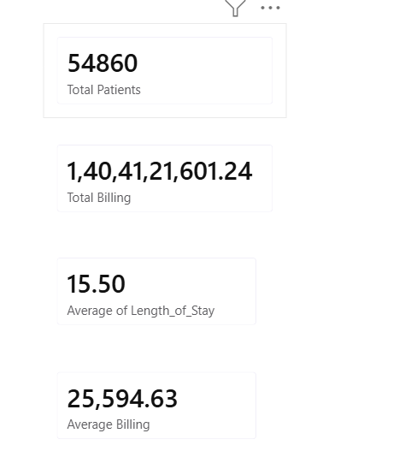
  - Add a Line Chart mapped to Total Patients by Year.

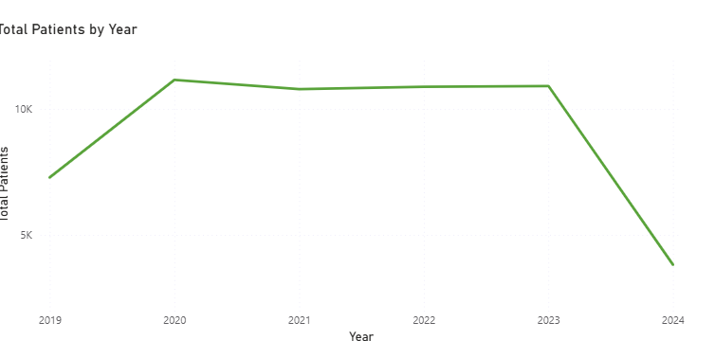

  - Add a Clustered Bar Chart for for Total Patients by Insurance Provider

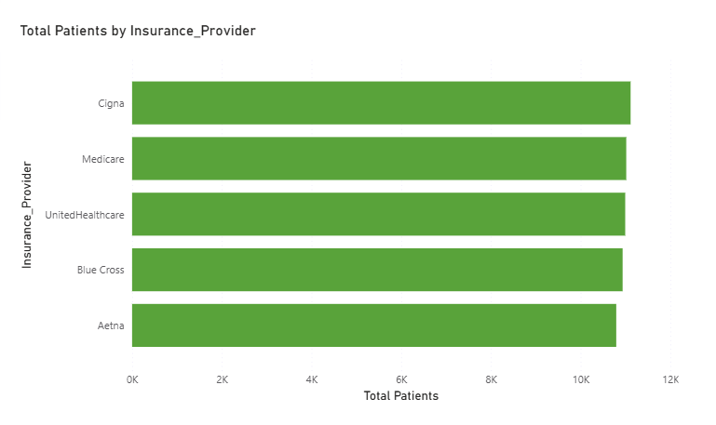
- Add a Donut Chart for Total Patients by Age Group.
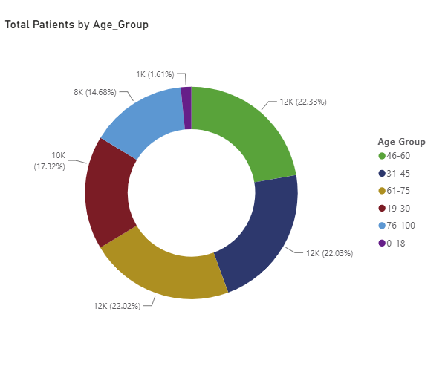
- Add Slicers for Gender and Hospitals.
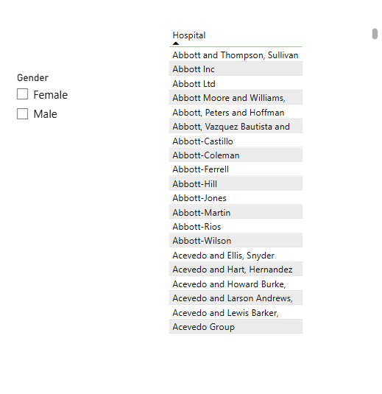

- Add Pie Chart for Total Patients by Gender and Test Results.
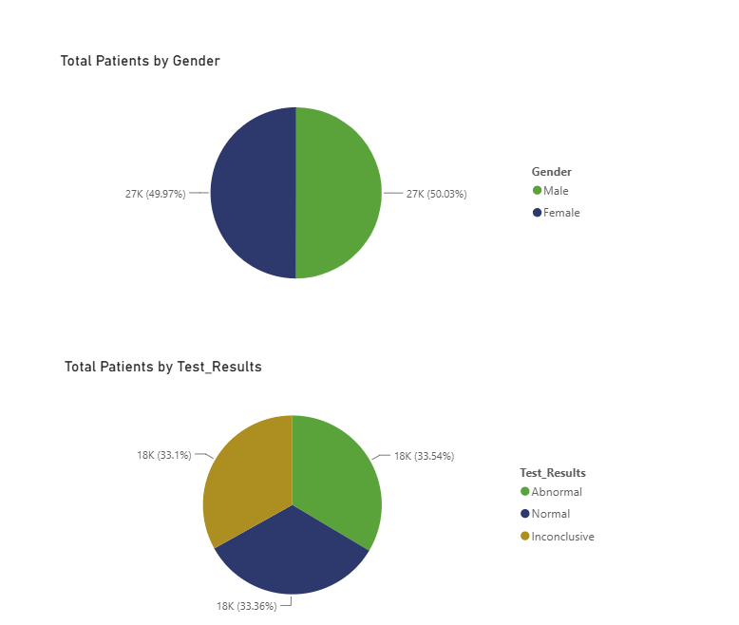

- Add Clustered Column Chart Total Patients by Admission type and Medical Condition

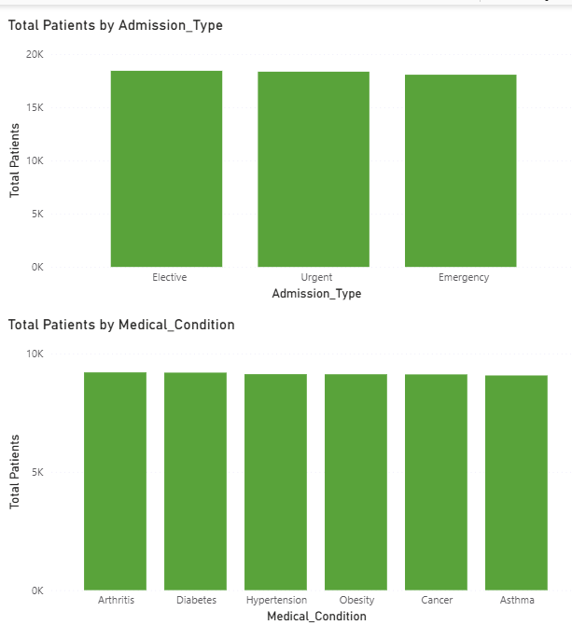

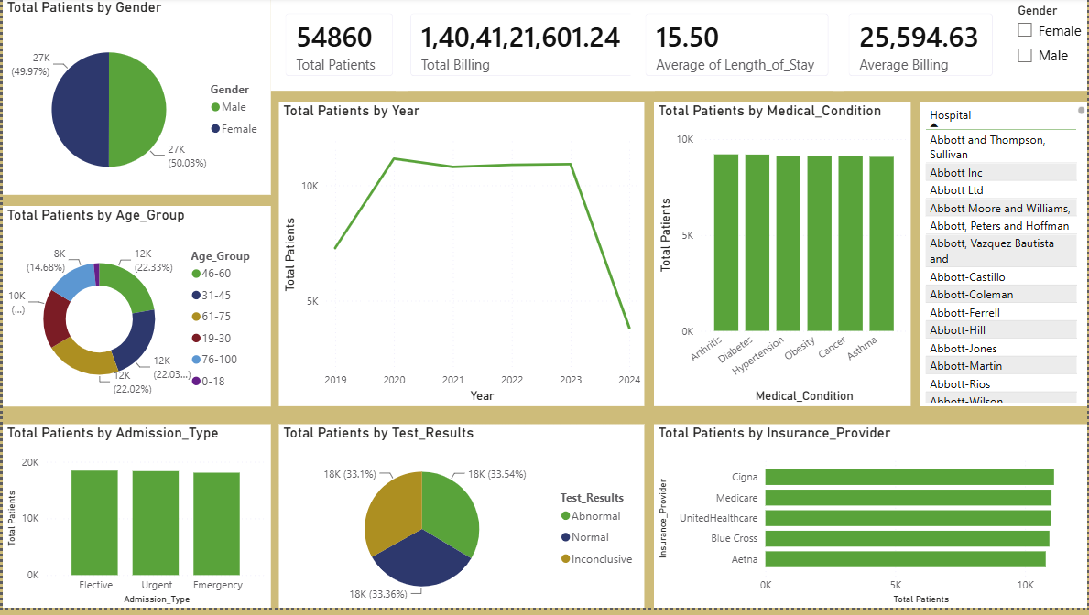
Step 5: Tableau Data Connection & Preparation
- Open Tableau Desktop / Tableau Public.
- Under Connect, select Text File.
- Select the cleaned dataset healthcare_cleaned.csv.
- Review the imported fields and verify the data types.
- Use the cleaned healthcare data to create worksheets and visualizations.
- Prepare the data for dashboard development using fields such as Medical Condition, Gender, Admission Type, Billing Amount, Length of Stay, and Date of Admission.

- Load the Healthcare cleaned dataset
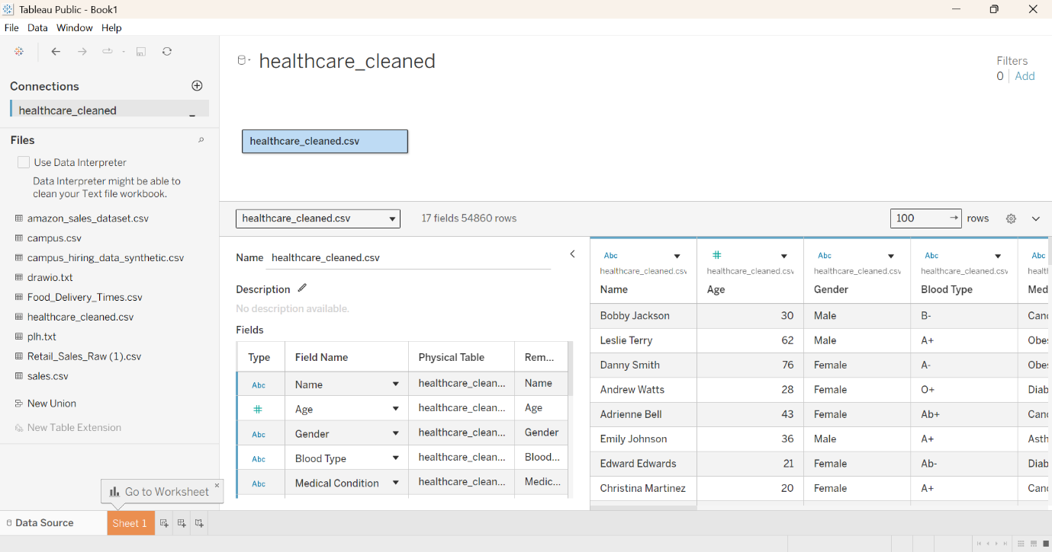

- Add calculations to create billing category
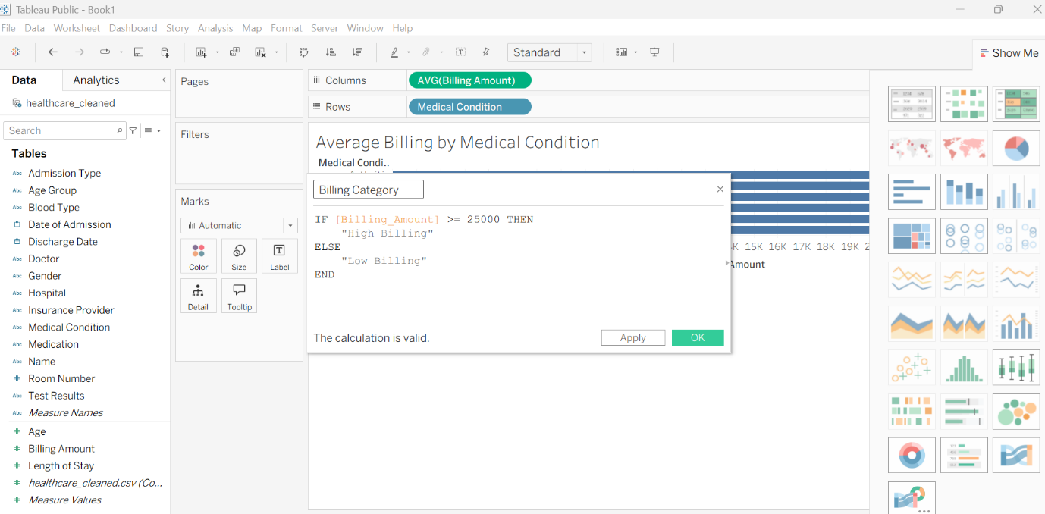

- Add Column chart for Patients by Admission Type

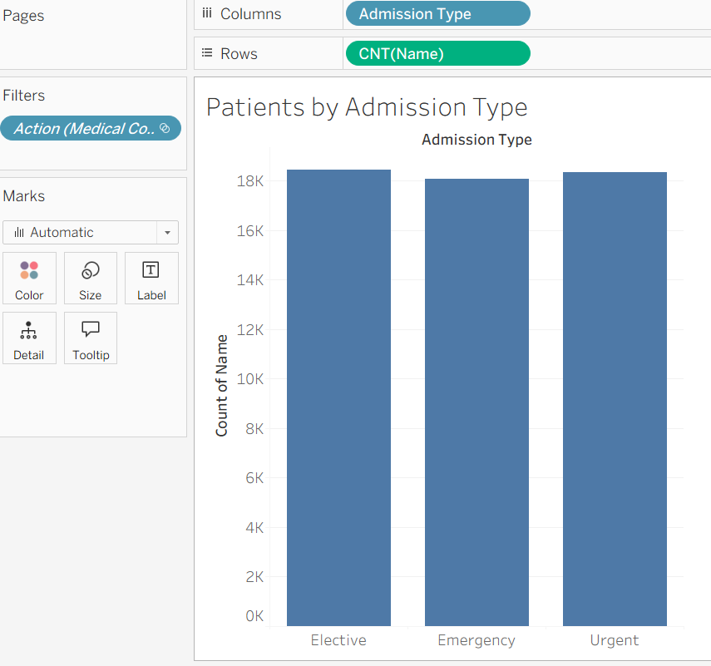

- Add Pie chart for Gender Distribution

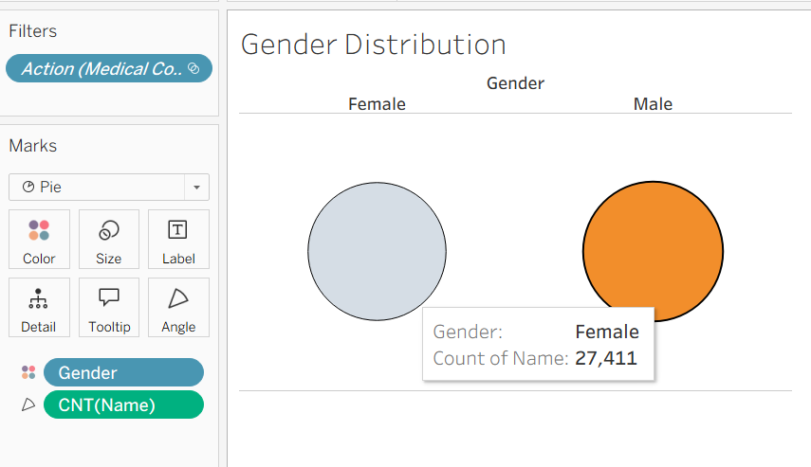

- Add Line Chart for Patients by Year

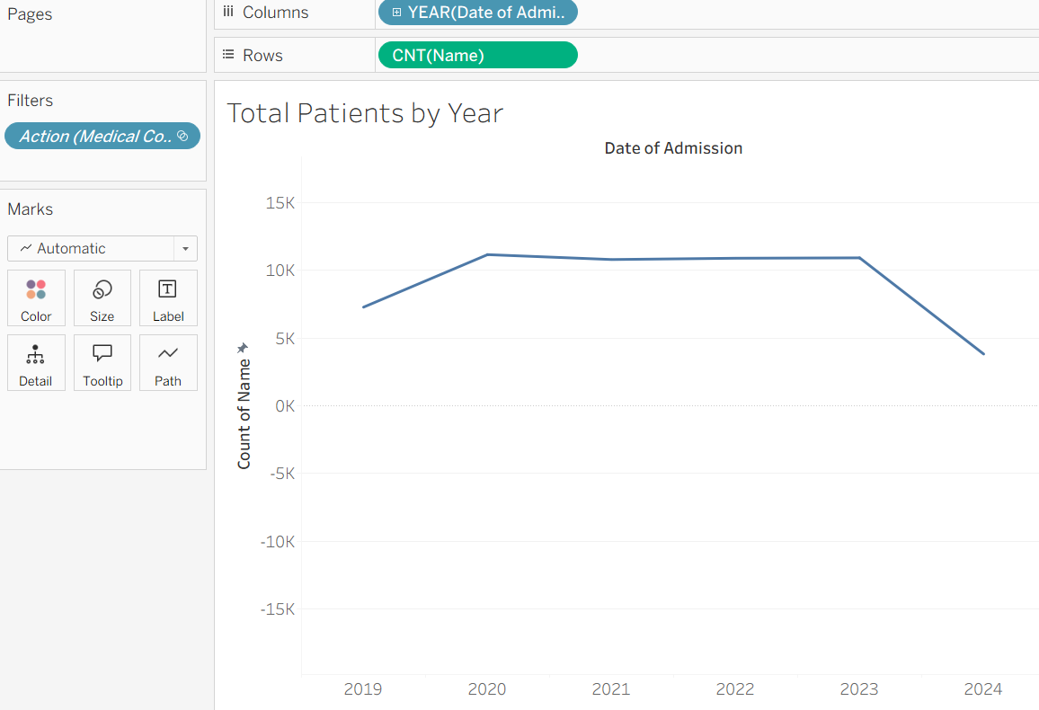
- Add Bar chart for Average billing by medical condition

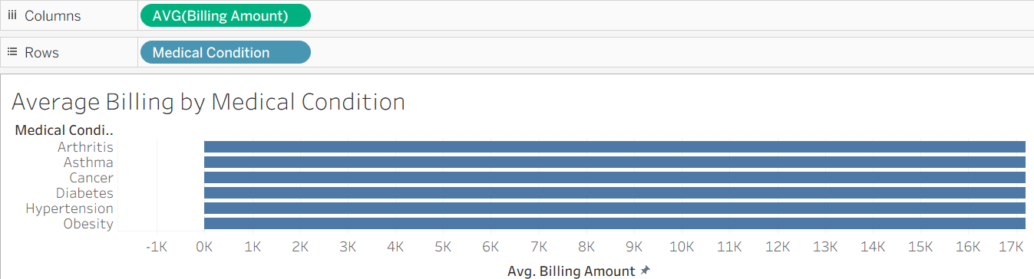
- Add Column chart for Dynamic Billing Category
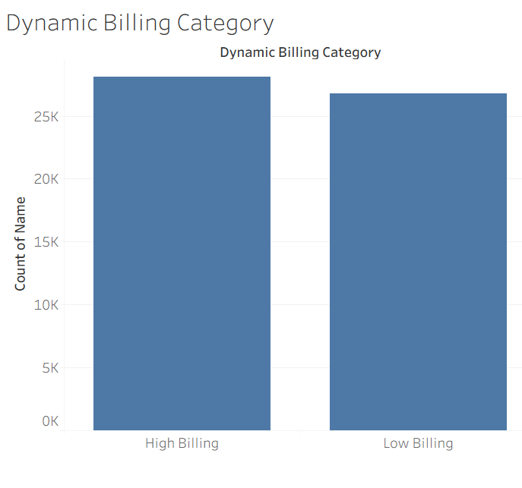
- Add Scatter Plot for Billing vs Length of Stay

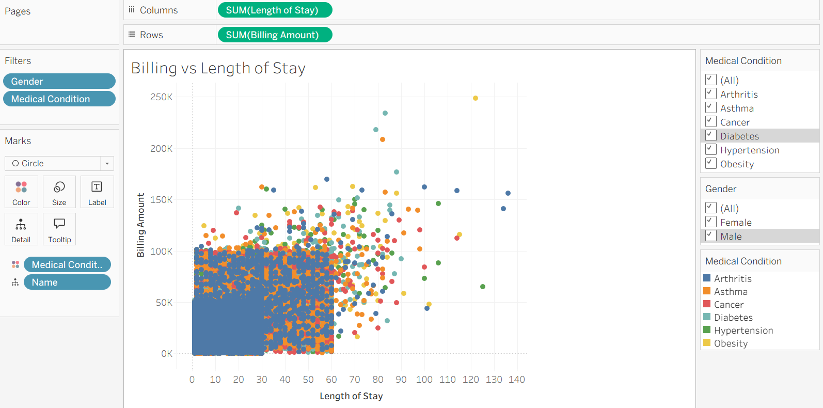

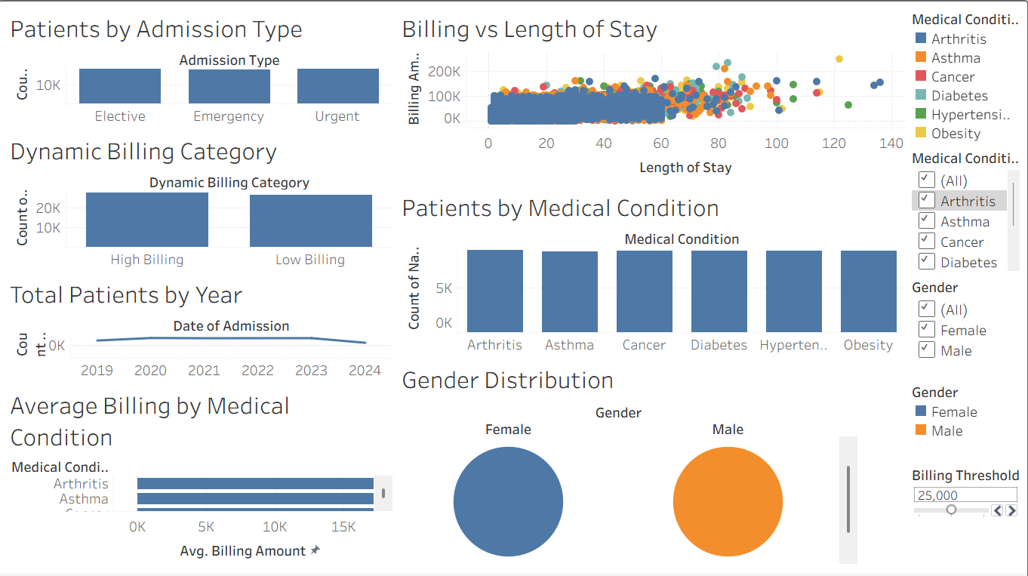

Observed Insights:
- Patient Volume:
The cleaned dataset contains 54,860 patient records after removing duplicate records and invalid billing values.
- Medical Condition Distribution:
The patient records are distributed across major medical conditions including Arthritis, Diabetes, Hypertension, Obesity, Cancer, and Asthma, providing a basis for comparing patient volumes across conditions.
- Admission & Patient Demographics:
Patients are categorized by Gender, Age Group, and Admission Type such as Emergency, Elective, and Urgent, allowing analysis of demographic and admission patterns.
- Billing & Hospital Stay:
Billing amounts and Length of Stay can be analyzed to understand healthcare utilization and identify high-billing patient records.
- Yearly Patient Trends:
The admission dates cover 2019 to 2024, enabling analysis of patient admission trends over time using Power BI and Tableau dashboards.
- Interactive Analysis:
Power BI and Tableau dashboards provide interactive filtering based on Gender, Medical Condition, and Hospital, helping users explore patient and hospital-level patterns.

